Ashley Net Pricing Exception App
Browing App 1
Screen Shot 1
Database Logic 2
Show records on exception screen. 4
Export to Excel. 4
Upload List from Excel. 4
Upload file Validation 5

Browing App
Browser URL dev.ashleynet.com and login.
choose account name
visit File MaintananceCustomer Maintainance Pricing Master

Screen Shot
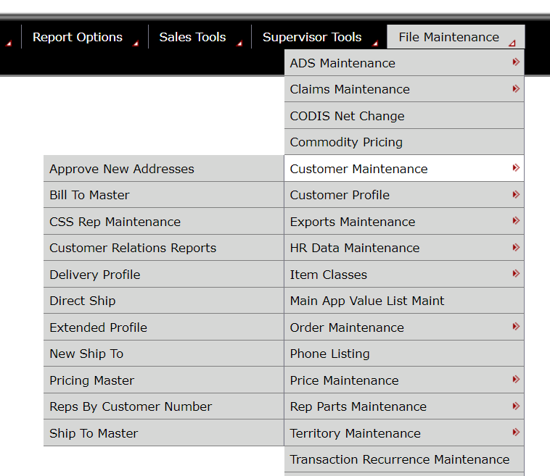
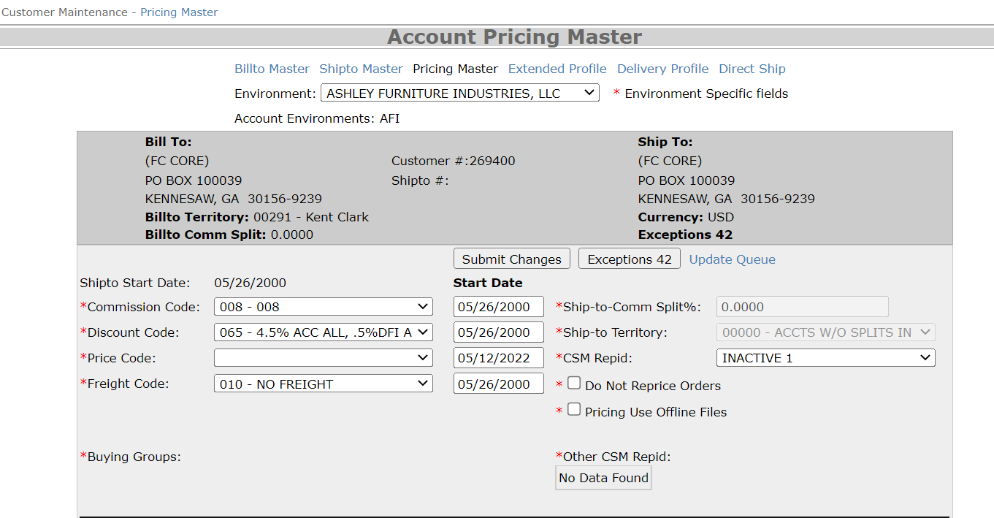
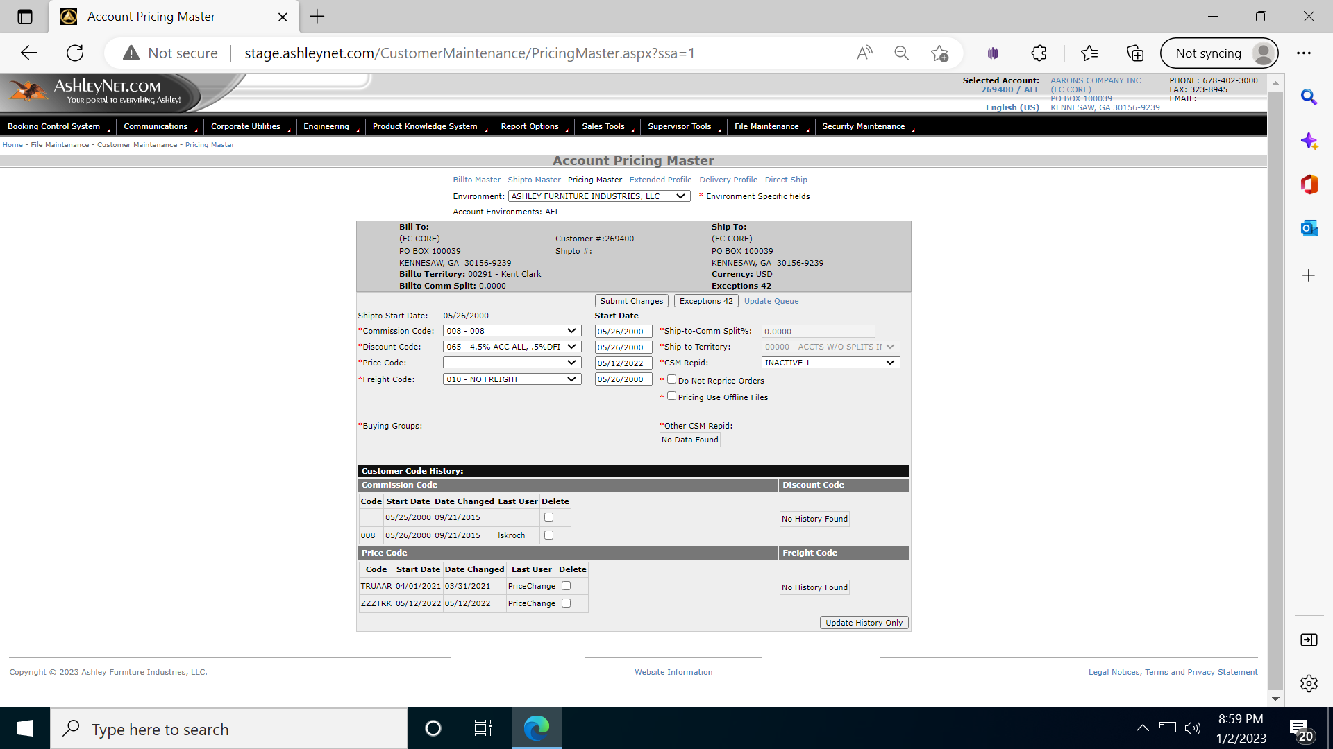

Database Logic

- Above screen will show value of Address from Stored Procedure: Ashley.dbo.usp_ShiptoAddress
- Bill To value is showing from SP: Ashley.dbo.usp_PricingMasterShippingInformation
- Value of Exception button will be shown using below Query.

SELECT COUNT(0) AS ExceptionCount FROM EXCPTN
WHERE ECUSNO = CUSTOMERNUMBER AND ESHPNO = SHIPTONUMBER
AND EORDNO = ''

- Above screen will show value of Commission Code, Discount Code, Price Code & Freight Code from below DB table Ashley.dbo.tblCustomerShippingLocations
Stored Procedure used: Ashley.dbo.usp_PricingMasterShippingInformation 8888600,’’
- Tables used for dropdown value.
- Commission Code dropdown is from table tblCommissionCodes, selected value= cslCommissionCode
Stored Procedure used:
Ashley.dbo.usp_PricingMasterLoadDropDowns "@type", "COMMISSION"
- Discount Code dropdown is from table tblDiscountCodes, selected value= cslDiscountCode
Stored Procedure used:
Ashley.dbo.usp_PricingMasterLoadDropDowns "@type", "DISCOUNT"
- Price Code dropdown is from table tblPriceCode, selected value= cslPriceCode
Stored Procedure used:
Ashley.dbo.usp_PricingMasterLoadDropDowns "@type", " PRICE"
- Freight Code dropdown is from table tblFreightCodes, selected value= cslFreightCode
Stored Procedure used:
Ashley.dbo.usp_PricingMasterLoadDropDowns "@type", " FREIGHT"
- Start Date for respective code is populating from Table: Ashley.dbo.tblCustomerPricingSetup and based on field cslTerritoryEffectivityDate

- Buying Group will be shown using SP: Ashley.dbo.usp_PricingMasterBuyingGroups

- Pricing History will be shown using SP: Ashley.dbo.usp_CustomerPricingChanges

While click on button Exception records will show from Database table: Ashley.dbo.tblPriceExceptions
Below is the screen shot.?

After click on button Save records are inserted in tables : tblPriceExceptions & tblCommissionAdjDtlExceptions

Show records on exception screen.
Stored Procedure: Ashley.dbo.usp_CommissionAdjustmentPriceExceptions
Below is the main query which is used to show records on exception screen inside stored procedure.
select pexItnbr,pexCusno,pexShpno,pexWhse,pexPrice,pexDisc1 dtddis,pexDisc2 minusdis,
pexDisc3 misdis,pexDisc4 coopAdd,pexDisc5 misdis2,
pexDisc6 Dfidis,pexDisc7 plusdis,pexEfrtyn Frt,pexDate1,pexDate2,
pexEocmmp Cmsn ,pexEcmadj Cbase,pexEbpred

from tblPriceExceptions where pexCusno=269400 and pexShpno=''
and pexItnbr='1010488'
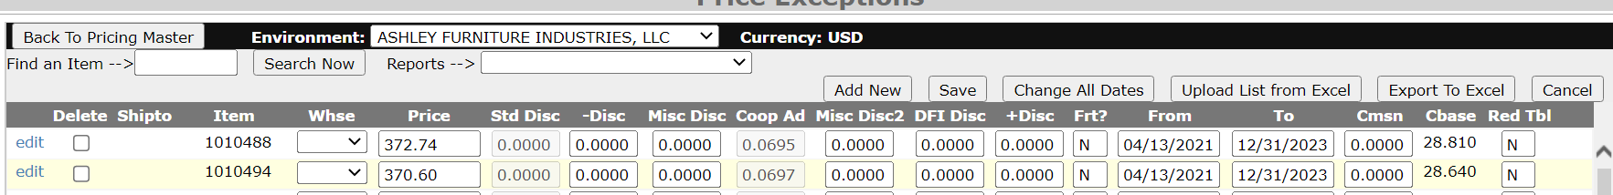

Export to Excel.
Below screen will show when click on button Export to Excel
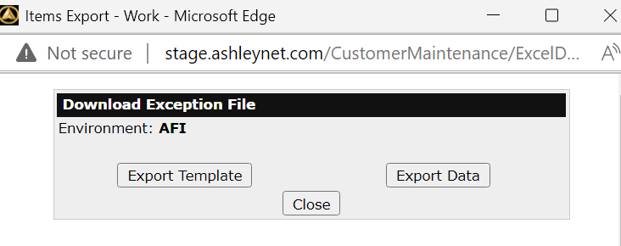
At above screen button Export Template will download excels containing only header and default value in first row.
Button Export data will download whatever is showing in grid of exception screen.

Upload List from Excel.
Below screen will show when click on button Upload List from Excel
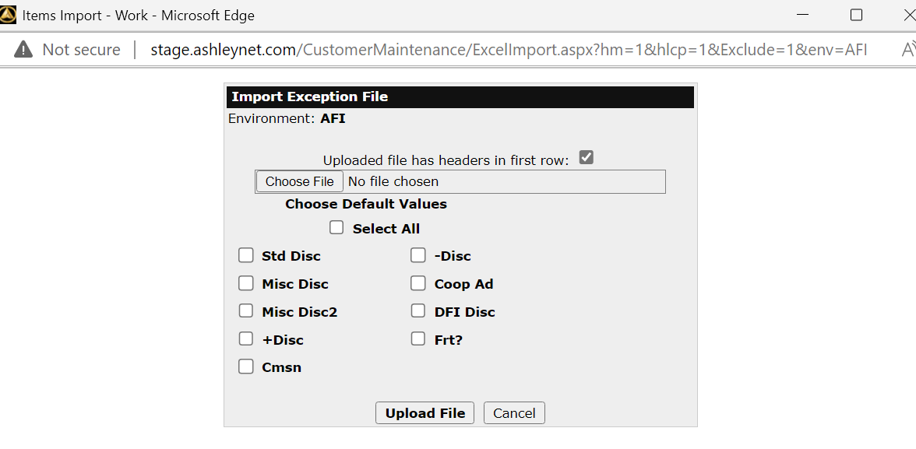
Based on above screen, user will choose file. They can select checkbox for respective default value and then click on button Upload File.
Discount related value is applied based on Stored Procedure name: [Ashley].[dbo].[usp_ExceptionDiscountInformation]: This SP is based on value of (Customer Number, Shipto, Item, From and to) while getting discount related value.
Here Shipto value is not picked from excel instead It is picked while choosing customer name and shipto.

Upload file Validation
Below is the field value inside excel file which should have valid value. For example, header marked with color yellow should not be mandatory on the other hand mandatory fields are Item, Price, From, To, Cbase and Red Tbl.
When user make entry inside header which is marked as yellow color, this should be maximum 9.99

Ashley Net Alert Flow
Browse the URL: ShipToMaster.aspx?ssa=1&envSelected=AFI
When modify below field like store name and Address then UI function “cmdSubmitShipping_Click” is executed.
Inside above function UpdateActiveShippingStatus() & UpdateShippingInformation() executed. Function UpdateAddressInformation is calling API to do some work.
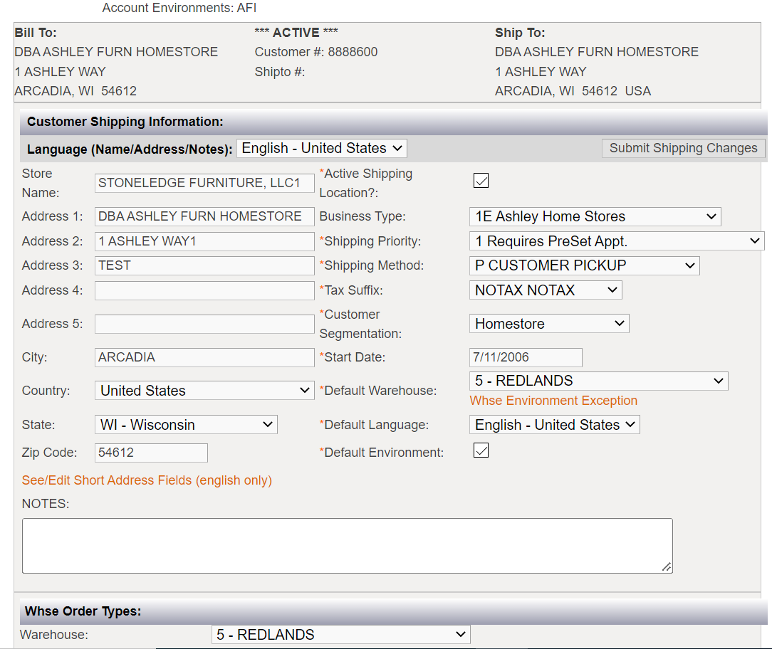
Above information is display by function LoadMainShippingInformation that in turn call stored procedure EXEC Ashley.dbo.usp_ShiptoMainShippingInformation
Below is the description of SP which is showing address information:

Main Table:
- Ashley.dbo.tblCustomerShippingLocations(cslCustomerNumber,cslShiptoNumber)
- tblCustomerShippingLocations_ML(cslName,cslLanguageCode,cslCustomerNumber,cslShiptoNumber)

- tblCustomerShippingLocations.cslBuyerAddressID=tblPartyAddressMaster.paaAddressID
- tblPartyAddressMaster_ML
(Address will show from above table based on paaLanguageCode & paaAddressID)

Question: Why we are maintaining same records in table tblPartyAddressMaster & tblPartyAddressMaster_ML

Based on output of above stored procedure, If "acrec" = "A" then
hdnActiveLocation.Value = True
To work property for the function UpdateActiveShippingStatus hdnActiveLocation.Value should equal to True.

Query or SP inside UpdateActiveShippingStatus
(This is executed 1st in sequence)
Below Query and Stored procedure are executed while function is called.
Ashley.dbo.tblCustomerShippingLocations are updated for fields (csmshpa1, csmshpa2, csmshpa3, csmcounty..)
Ashley.dbo.tblExtendedCustomerProfile are also updated for fields (ecpGeoLat, ecpGeoLong)
UPDATE Ashley.dbo.tblCustomerShippingLocations
SET acrec='A' WHERE cslCustomerNumber=? AND cslShiptoNumber=?
EXEC Ashley.dbo.usp_ShiptoSetDefaultContacts
EXEC Ashley.dbo.usp_ContactsSetDefaultsForCustomer
EXEC Ashley.dbo.usp_ShiptoSetDefaultContacts
EXEC Ashley.dbo.usp_ContactsSetDefaultsForCustomer
SELECT count(*) as recordCount FROM Ashley.dbo.tblCustomerProfile
WHERE cupPartnerID=CUSTOMERNUMBER AND cupLocationID=SHIPTONUMBER

EXEC Ashley.dbo.usp_CheckCustomerProfileSetup
EXEC Ashley.dbo.usp_ShiptoMasterHSBlocking
EXEC Ashley.dbo.usp_CustMaintUpdateHandlingCharges
SELECT count(*) as recordCount
FROM DB2SQL.dbo.COMAST WHERE CUSNO=? AND SHPNO=?
UPDATE Ashley.dbo.tblCustomerShippingLocations
SET acrec='S'
WHERE cslCustomerNumber=?
AND cslShiptoNumber=?
EXEC Ashley.dbo.usp_ShiptoSuspendProfiles

Query or SP inside UpdateShippingInformation
(It is executed 2nd in sequence, and this does not update address part)
Below Query and Stored procedure are executed while function is called.
First It will check envcode based on below query.
select ensEnvironmentCode FROM Environment.dbo.tblEnvironmentServers
where ensDatabaseServer=@@SERVERNAME
If envCode='WVF' this applies some logic for field country & region.
EXEC Ashley.dbo.usp_ShiptoUpdateGlobalInformation (must be called)
EXEC Ashley.dbo.usp_ShiptoUpdateAddressGlobal (It is main SP which updates address)
Above SP is executed in Server: GARCWIVDSQG\GBL_DDYNAMIC
Below SP is executed in Server: AARCWIVDSQD\AFI_DDYNAMIC
EXEC Ashley.dbo.usp_ShiptoUpdateShippingInformation (must be called)
EXEC Ashley.dbo.usp_ShiptoUpdateNonEnvInformation (must be called)
EXEC Ashley.dbo.usp_ShiptoMasterHSBlocking
EXEC Ashley.dbo.usp_ShiptoUpdateAddressInformation (This function is always executed which update table: tblCustomerShippingLocations & tblExtendedCustomerProfile)

Function inside UpdateAddressInformation
(It is executed 3rd step in sequence, and it updates address part)
Common.AshleyAddressValidation uses below API for validation of address1 and address2.
AshleyGeocode.Url= http://apifms.ashleyfurniture.com/ashleygeocoding/ GeocodeService.svc/GetGeocodeForANAddress?
This function checks that “AFI_Dynamic” should match with below query.
SELECT cemEnvironment FROM Ashley.dbo.tblCustomerEnvironmentMaster where customer? And shipto?

Finally, below stored procedure is executed in Server: GARCWIVDSQG\GBL_DDYNAMIC
EXEC Ashley.dbo.usp_ShiptoUpdateAddressGlobal (It is main SP which updates address)
Above is either insert or update table: tblPartyAddressMaster_ML

SELECT @partyID=cemPartyID, @locationID=cemLocationID
FROM Ashley.dbo.tblCustomerEnvironmentMaster
WHERE cemCustomerNumber=@customerNumber
and cemShiptoNumber=@shiptoNumber
GROUP BY cemPartyID, cemLocationID

table: tblPartyLocations_ML is updated based on pltLocationID= locationID

SELECT @addressID=pltAddressID
FROM Ashley.dbo.tblPartyLocations with (nolock)
WHERE pltPartyID=@partyID
and pltLocationID=@locationID

table: tblPartyAddressMaster_ML is updatd based on paaAddressID=@addressID

